This document is a CONFIDENTIAL TRADE SECRET of Eclipse Identity Recognition Corporation (EclipseIR). No part of it may be transmitted, copied, distributed, or in any way shared without the express written permission of the CEO of Eclipse Identity Recognition Corporation. EclipseIR, INDIface, and FusionIR and their respective logos are trademarks of EclipseIR.
EclipseIR TM
Intellectual
Property

Initial Draft in Progress
December 12, 2012

Summary

Eclipse Identity Recognition Corporation TM provides Personal Identity Recognition via its face-based analytics known as INDIface TM. It is used to detect faces and facial features and then generate face templates for searching and matching. In addition, the INDIface analytics can also determine skin tone, upper and lower clothes color, and an estimated height of a person. The INDIbase TM system provides for the enrollment, storage, management, retrieval, and matching of INDIface templates. INDIface also manages facial and other images as well as personal identification and characteristic data.
The “Road to INDI (Integrated Network Digital Imaging)” began in January 2002 by recognizing that a convergence of automatic facial recognition, digital surveillance video and archiving, and access control was taking place. This in conjunction with realization that digital processing, communication, and storage capabilities were increasing while becoming more affordable. The concept was to use these trends to accomplish things in digital media that were previously unavailable on the desktop. Application sectors included transportation safety, gaming, retail, financial, corporate, law enforcement, and utilities.
In EclipseIR's initial generation, FusionIRTM, the INDIface Software Development Kit (SDK1), allows third-party developers to create custom applications using EclipseIR's technology. It runs on Microsoft Windows-based systems as a stand-alone console application with a capacity of over 50,000 enrollments. EclipseIR's own applications use exactly the same SDK available to OEM developers.
While SDK1 is essentially single-threaded, the second generation of INDIface (If²) will focus on multiple threads to split the work across multicore, multiprocessor servers, and even, multiple-server (i.e. blade) systems. If² will introduce an SQL-based INDIbase enrollment repository and a plug-in Frame Source Architecture and an Image Manager Service to accept video channels from a wider variety of sources.
In the second generation, FusionIR will be wrapped in two architectures. The second generation software development kit (SDK2) will mimic the interface of SDK1. An application program interface (API2) will be based upon messages passed via TCP/IP sockets; the command, control, and configuration packets can be between applications on a single system or across a wide area network. Both SDK2 and API2 can be implemented as Windows services and 'BSD/Linux daemons. The API2 will serve as the basis for interfacing with other standard APIs, such as BioAPI and the Onvif SOAP standard for video analytics.
This document will ....

Overview
INDIface, EclipseIR Applicaitons, and Other Intellectual Property
This section will ...

Core Technology
The INDIface system
This chapter will...

The basic operations of INDIface can be broken into five functional blocks in addition to the separate processes for INDIbase and Image Manager Service SQL interfaces: Frame Processing, Face Processing, Analytic Processing, Template Processing, and Result Fusion.
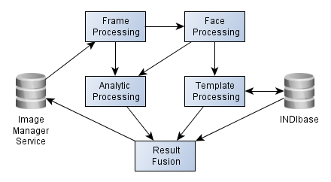
Frame Processing receives frames from the Image Manager Service transforms it and then pre-processes it by skin detection, variance detection, and luminance stretching. Regions of interest are then processed for frontal-face object detection.
Face Processing involves detecting face features, determining which set of face feature locations is optimum, normalizing the face image based upon the best feature locations, and calculating one or more vectors for the normalized face.
Analytic Processing currently has three components which can be performed in parallel for each qualified face: (1) Extracting characteristic face color pixels from the normalized face image and calculating the face's skin color. (2) Extracting characteristic color pixels below the detected face in the input frame and determining the clothes color of upper and lower body. (3) Based upon the feature locations, estimate the height of the person belonging to the face.
Template Processing includes sorting face vectors by similarity of match to enrolled vectors and management of the enrollment of persons and their face vectors (collected into templates).
Results Fusion is the final destination for each input frame. The results from all of the other processes are collected, evaluated, and distributed to the appropriate places.

Timeline

2008 | JAN | Begin Face Detector Development
2008 | MAR | Basic IP camera and “hotdir” Input
2008 | MAY | Multi-face Detection
2008 | AUG | Begin INDIface Development
2009 | DEC | Complete Basic INDIface Functionality:  - Eye Location  - Template Generation  - Template Storage  - Casual Matching  - Formal Search  - Enrollment  - Person-Mode
2010 | JAN | Search/Verify Command
2010 | MAR | Enroll/Delete Command  Enroll/Remove Command
2010 | APR | Enroll/Rename Command
2010 | MAY | Clothes Color Matching  Skin Tone Matching
2010 | JUN | Height Estimation  Resolver Integration
2010 | SEP | Enroll/RemoveAll Command
2010 | OCT | Pre-Processing Transform  Input/Start-End Time Specification
2011 | FEB | Completed Port to Linux
2011 | APR | Retrieve Status & PersonReport  SDK Reference Document Released
2011 | MAY | Improved Height Estimator
2011 | DEC | Dynamic Authentication
2012 | OCT | Manual Enrollment

EclipseIR Applications
MatchPointIR, SearchPointIR, ResolverIR
This chapter will ...

The BAGger
Rapid Biometric Application Generation
This chapter ...

Other IP
.
This chapter will ...

Prior Art
Haar Detection & EigenFace
This chapter will ...

Third Party Tools
.

IP Protection
How EclipseIR will protect its Intellectual Property
This chapter will ...

Patent
EclipseIR will ...

Copyright
EclipseIR will ...

Trademark & Other Marks
EclipseIR will ...

Trade Secret
EclipseIR will ...

Other Protection
EclipseIR will ...

Frame Processing
Pre-processing & Object Detection

Social Media Imaging
Categorizing Scattered Stills

Patent:
Status: | Blue Sky | Version: | 3 or 4
Requires: | Skin Detection, Edge Detection | Allows: | Further automated setting of frontal face detection parameters.
Predecessor: | Automatic Optimization | Successor:
Competition: | None
Descriptive Drawing:
Claims:
Comments:

By analyzing a skin detection map and detected shape edges, we try to categorize individual still images and automatically set the minimum and maximum persons across parameters:

Solo | Duo | Trio
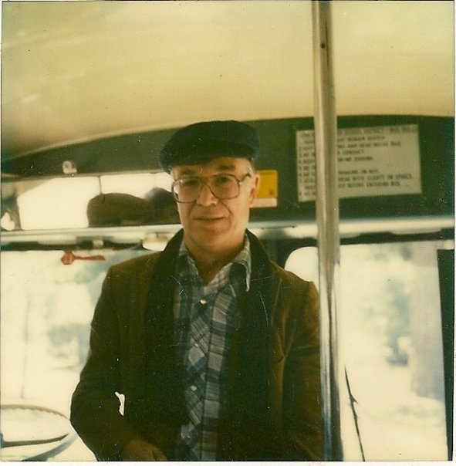 |  | 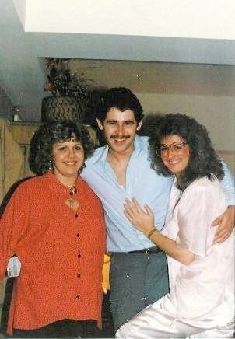
MinAcross=0; MaxAcross=2 | MinAcross=1; MaxAcross=3 | MinAcross=2; MaxAcross=4
Group | Crowd | Class
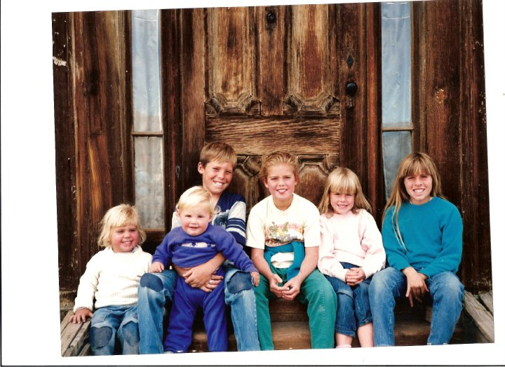 | 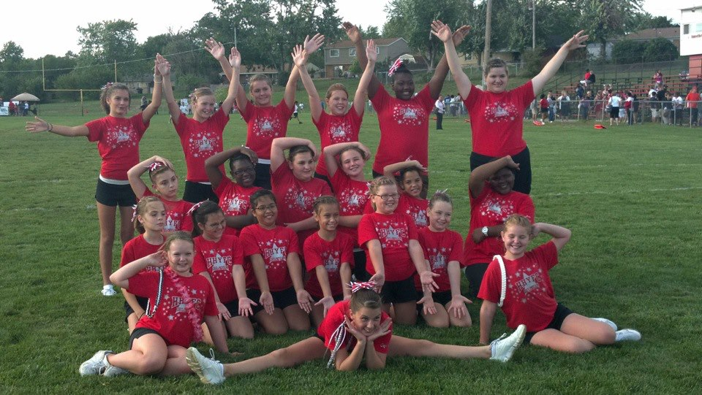 | 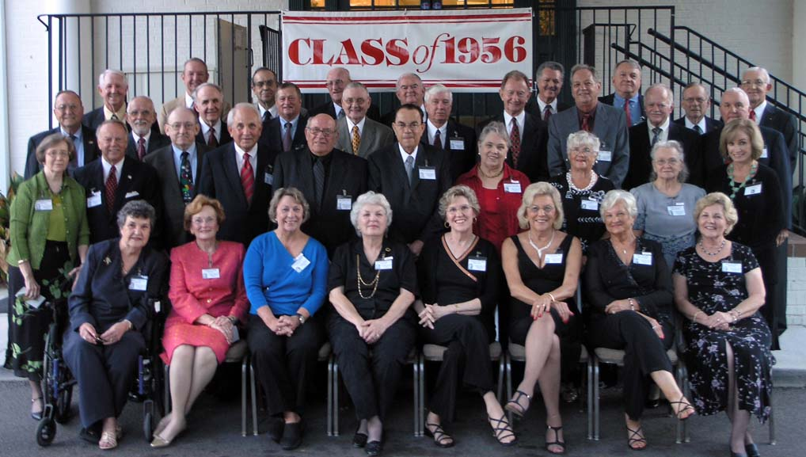
MinAcross=4; MaxAcross=10 | MinAcross=10; MaxAcross=20 | MinAcross=12; MaxAcross=0

Multiple Resolutions
Using the Appropriate Pixel Density

Patent:
Status: |  | Version:
Requires: |  | Allows:
Predecessor: |  | Successor:
Competition:
Descriptive Drawing:
Claims:
Comments:

Color Correction

Detecting Color Shift and Counter Correcting

For reliable skin and face color detection, color shifts from cameras need to be detected and corrected.

Patent:
Status: |  | Version:
Requires: |  | Allows:
Predecessor: |  | Successor:
Competition:
Descriptive Drawing:
Claims:
Comments:

Named Regions
Only Look for Faces Where They Are Expected
Allows users to define named regions of interest, so areas not included in those regions do not have to be scanned, reducing the processing time and allowing parallelism.

Patent:
Status: |  | Version:
Requires: |  | Allows:
Predecessor: |  | Successor:
Competition:
Descriptive Drawing:
Claims:
Comments:

Skin Detection
Faces are Where Skin Can Be Seen
Within the named regions, we can eliminate areas with low skin tone.

Patent:
Status: |  | Version:
Requires: |  | Allows:
Predecessor: |  | Successor:
Competition:
Descriptive Drawing:
Claims:
Comments:

Green/Grey < 0.4 && Blue/Grey < 0.45 loose skin detector.

Variance Detection
Faces Are Not In Flat Areas
Also within the named regions areas that have very little variance of luminance can be ignored.

Patent:
Status: |  | Version:
Requires: |  | Allows:
Predecessor: |  | Successor:
Competition:
Descriptive Drawing:
Claims:
Comments:

Lighting Correction
.

Patent:
Status: |  | Version:
Requires: |  | Allows:
Predecessor: |  | Successor:
Competition:
Descriptive Drawing:
Claims:
Comments:

Luminance Stretching
Bringing Faces From The Shadows
For dark or washed out images we can perform luminance stretching to bring out hidden details.

Patent:
Status: |  | Version:
Requires: |  | Allows:
Predecessor: |  | Successor:
Competition:
Descriptive Drawing:
Claims:
Comments:

Watermark Removal
.

Patent:
Status: |  | Version:
Requires: |  | Allows:
Predecessor: |  | Successor:
Competition:
Descriptive Drawing:
Claims:
Comments:

Pre-Processing Results
Combining the Face Regions

Patent:
Status: |  | Version:
Requires: |  | Allows:
Predecessor: |  | Successor:
Competition:
Descriptive Drawing:
Claims:
Comments:

Automatic Optimization
Selecting the Appropriate Parameters
The minimum and maximum size of the expected face or eye to be detected can be set by INDIface parameters; this can improve speed and reduce false detections.

Patent:
Status: |  | Version:
Requires: |  | Allows:
Predecessor: |  | Successor:
Competition:
Descriptive Drawing:
Claims:
Comments:

Frontal Face Detection
.
The base for INDIface object detection is the Haar Classifier Cascade mechanism provided by the Intel's OpenCV computer vision library. INDIface first scans an image or a single frame of video for potential frontal faces. At this time we do not correlate objects from one frame to the next.

Patent:
Status: |  | Version:
Requires: |  | Allows:
Predecessor: |  | Successor:
Competition:
Descriptive Drawing:
Claims:
Comments:

Results Grouping
.
The base object detector returns a list of rectangles of the original frame that "might" contain the desired object. INDIface has several methods with adjustable parameters that can be used to group the raw detections in different ways that can be adjusted for a particular application.

Patent:
Status: |  | Version:
Requires: |  | Allows:
Predecessor: |  | Successor:
Competition:
Descriptive Drawing:
Claims:
Comments:

Pose Detection
.

Patent:
Status: |  | Version:
Requires: |  | Allows:
Predecessor: |  | Successor:
Competition:
Descriptive Drawing:
Claims:
Comments:

Pose Correction
.

Patent:
Status: |  | Version:
Requires: |  | Allows:
Predecessor: |  | Successor:
Competition:
Descriptive Drawing:
Claims:
Comments:

Custom Detectors
?

Patent:
Status: |  | Version:
Requires: |  | Allows:
Predecessor: |  | Successor:
Competition:
Descriptive Drawing:
Claims:
Comments:

Face Processing
Feature Location & Template Generation

Patent:
Status: |  | Version:
Requires: |  | Allows:
Predecessor: |  | Successor:
Competition:
Descriptive Drawing:
Claims:
Comments:

Face Scaler
?

Patent:
Status: |  | Version:
Requires: |  | Allows:
Predecessor: |  | Successor:
Competition:
Descriptive Drawing:
Claims:
Comments:

Eye Detection
.
Once a potential face is located we scan the face area of the image for potential left and right eyes. The potential eye location pairs are passed to the template generation process.

Patent:
Status: |  | Version:
Requires: |  | Allows:
Predecessor: |  | Successor:
Competition:
Descriptive Drawing:
Claims:
Comments:

Custom Eye Detector
.

Patent:
Status: |  | Version:
Requires: |  | Allows:
Predecessor: |  | Successor:
Competition:
Descriptive Drawing:
Claims:
Comments:

Template Consistency
.

Patent:
Status: |  | Version:
Requires: |  | Allows:
Predecessor: |  | Successor:
Competition:
Descriptive Drawing:
Claims:
Comments:

Reconstruction _
.

Patent:
Status: |  | Version:
Requires: |  | Allows:
Predecessor: |  | Successor:
Competition:
Descriptive Drawing:
Claims:
Comments:

Feature Location
.

Patent:
Status: |  | Version:
Requires: |  | Allows:
Predecessor: |  | Successor:
Competition:
Descriptive Drawing:
Claims:
Comments:

Face Feature Congruence
.

Patent:
Status: |  | Version:
Requires: |  | Allows:
Predecessor: |  | Successor:
Competition:
Descriptive Drawing:
Claims:
Comments:

Eigenface Process
.

Patent:
Status: |  | Version:
Requires: |  | Allows:
Predecessor: |  | Successor:
Competition:
Descriptive Drawing:
Claims:
Comments:

Custom Eigenface Layers
.

Patent:
Status: |  | Version:
Requires: |  | Allows:
Predecessor: |  | Successor:
Competition:
Descriptive Drawing:
Claims:
Comments:

Extensive Enroll Template
.

Patent:
Status: |  | Version:
Requires: |  | Allows:
Predecessor: |  | Successor:
Competition:
Descriptive Drawing:
Claims:
Comments:

Visual Demographics
Determining Apparent Age, Gender, & Race

Patent:
Status: |  | Version:
Requires: |  | Allows:
Predecessor: |  | Successor:
Competition:
Descriptive Drawing:
Claims:
Comments:

Multiple Vector Template
.

Patent:
Status: |  | Version:
Requires: |  | Allows:
Predecessor: |  | Successor:
Competition:
Descriptive Drawing:
Claims:
Comments:

Variable Vector Length
.

Patent:
Status: |  | Version:
Requires: |  | Allows:
Predecessor: |  | Successor:
Competition:
Descriptive Drawing:
Claims:
Comments:

Template Management
Storage and Matching for Extremely Large Databases

Patent:
Status: |  | Version:
Requires: |  | Allows:
Predecessor: |  | Successor:
Competition:
Descriptive Drawing:
Claims:
Comments:

Face Repository
Millions of Categorized Face and Frame Images

Patent:
Status: |  | Version:
Requires: |  | Allows:
Predecessor: |  | Successor:
Competition:
Descriptive Drawing:
Claims:
Comments:

Database Segmentation
Prioritizing Search by Vector Characteristics

Patent:
Status: |  | Version:
Requires: |  | Allows:
Predecessor: |  | Successor:
Competition:
Descriptive Drawing:
Claims:
Comments:

Face-based Analytics
.

Patent:
Status: |  | Version:
Requires: |  | Allows:
Predecessor: |  | Successor:
Competition:
Descriptive Drawing:
Claims:
Comments:

Resolver
.

Patent:
Status: |  | Version:
Requires: |  | Allows:
Predecessor: |  | Successor:
Competition:
Descriptive Drawing:
Claims:
Comments:

Applications
.

Patent:
Status: |  | Version:
Requires: |  | Allows:
Predecessor: |  | Successor:
Competition:
Descriptive Drawing:
Claims:
Comments:

Other IP
.

Patent:
Status: |  | Version:
Requires: |  | Allows:
Predecessor: |  | Successor:
Competition:
Descriptive Drawing:
Claims:
Comments:

Reducing Network Traffic
Moving the Processing Closer to the Nodes

Patent:
Status: |  | Version:
Requires: |  | Allows:
Predecessor: |  | Successor:
Competition:
Descriptive Drawing:
Claims:
Comments:

The Future
Third Generation & Beyond
This section will detail ...

Face Profile
.

Patent:
Status: |  | Version:
Requires: |  | Allows:
Predecessor: |  | Successor:
Competition:
Descriptive Drawing:
Claims:
Comments:

“Half-Face”
Detecting Halves of Frontal Faces

Patent:
Status: |  | Version:
Requires: |  | Allows:
Predecessor: |  | Successor:
Competition:
Descriptive Drawing:
Claims:
Comments:

“Hemi-Face”
'tween Frontal and Profile

Patent:
Status: |  | Version:
Requires: |  | Allows:
Predecessor: |  | Successor:
Competition:
Descriptive Drawing:
Claims:
Comments:

Face Tracking
.

Patent:
Status: |  | Version:
Requires: |  | Allows:
Predecessor: |  | Successor:
Competition:
Descriptive Drawing:
Claims:
Comments:

IP Recap
.

Patent:
Status: |  | Version:
Requires: |  | Allows:
Predecessor: |  | Successor:
Competition:
Descriptive Drawing:
Claims:
Comments:

